Royal United Services Institute of Victoria
Lunchtime Address
Thursday 29th February, 2024 at 1200 for 1230
ANZAC House , 4 Collins St, Melbourne

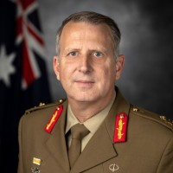

Major General Jason Blain, DSC, AM, CSC
Head, Land Systems , Capability Acquisition and Sustainment Group

Topic: The Army – Post Force Structure Review.

Major General Jason Blain was born in Mossman, north Queensland, and completed his schooling in Ingham. After attaining a Bachelor of Arts, he attended the Royal Military College Duntroon, graduating into the Royal Australian Infantry Corps in 1991. During his more than 30 years’ service, he has served in an extensive range of command appointments. As an Infantry officer he has commanded at all levels within the Royal Australian Regiment (RAR) and was the Commanding Officer of the 6th Battalion RAR from 2008 to 2009.
He was the Commander of the 7th Combat Brigade in Brisbane, one of Army’s three combat brigades, from 2020 to 2021. On promotion to Major General in 2022 he was appointed the Head of Armoured Vehicles. In December 2023 the Division was merged into the Land Systems Division and Major General Blain was appointed as the Head of Land Systems.
Coffee and Tea from 12.00 pm. Entrance fee: $10

